K.D.K COLLEGE OF ENGINEERING NAGPUR DEPARTMENT OF INFORMATION TECHNOLOGY

**“VIRTUAL ASSISTANT FOR DESKTOP”**

**Name of Student:- 1.Ashvini Khobragade 2.Rupali Mamale 3.Pranay Lohbare 4.Shashank Mankar Name of Guide:-Assist.Prof.Ganorkar**

**Abstract:-**his paper describes a research project to create a virtual assistant for computers that can perform various tasks using natural language and machine learning techniques.The virtual assistant is designed to assist users with tasks such as searching the web, managing files,scheduling, sending emails, etc.The implementation process uses a combination of speech recognition and speech management to enable users to interact with the spoken language assistant. The research project included several stages, including data collection and preprocessing, feature extraction, model training and evaluation, and system integration and experimentation. The data used for training and evaluation is collected from a variety of sources, including publicly available data and user interactions with the system.Video extraction process involves extracting relevant features from the material such as acoustic features, speech features and content features. The training model and evaluation phase will develop and evaluate different learning models for various tasks such aslanguage recognition, language comprehension and speech management.

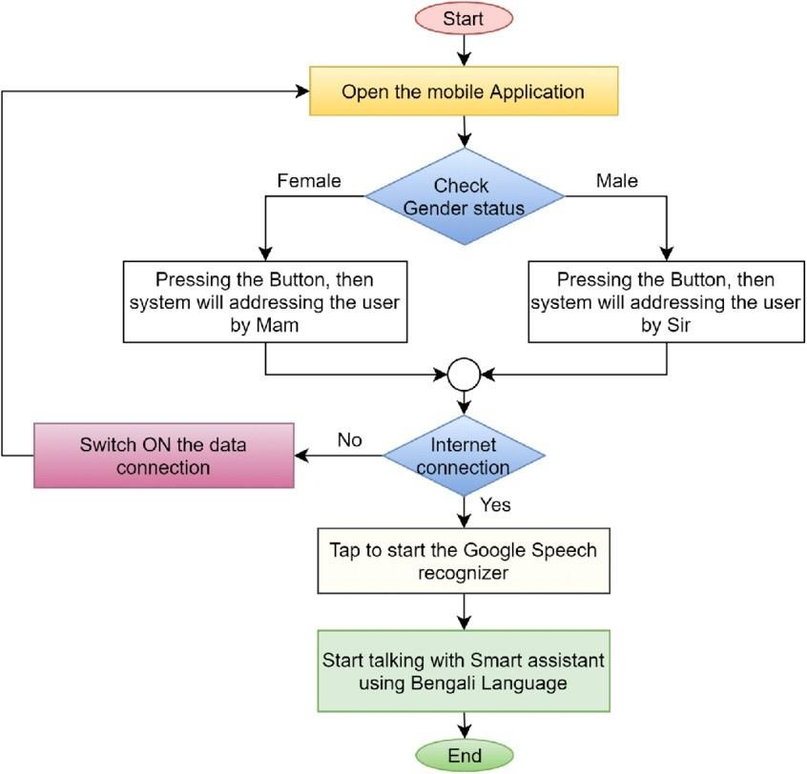

**Flowchart:-**

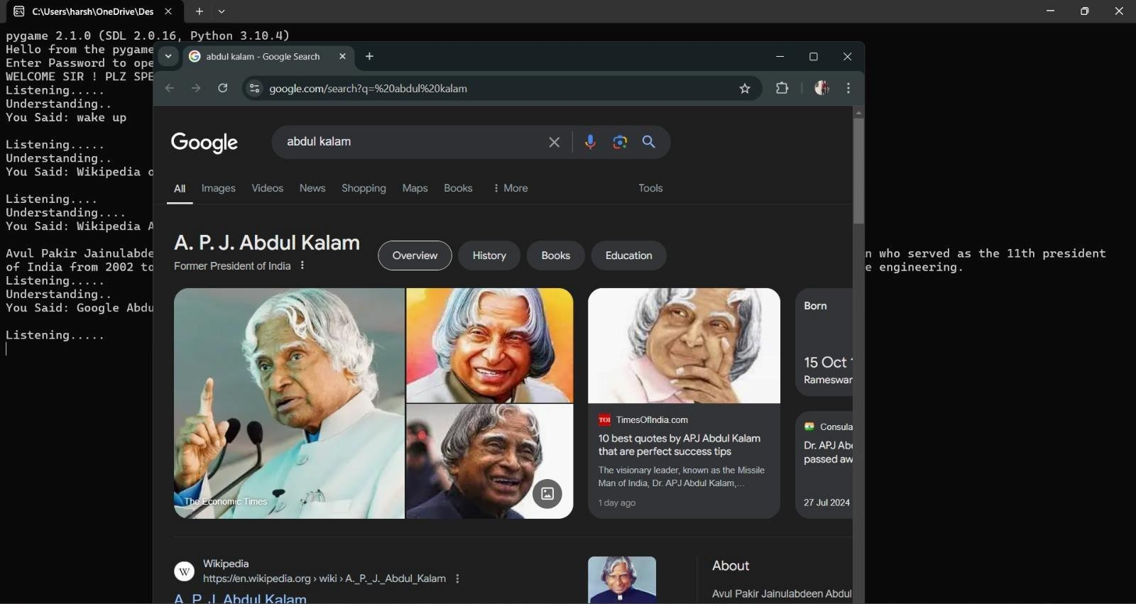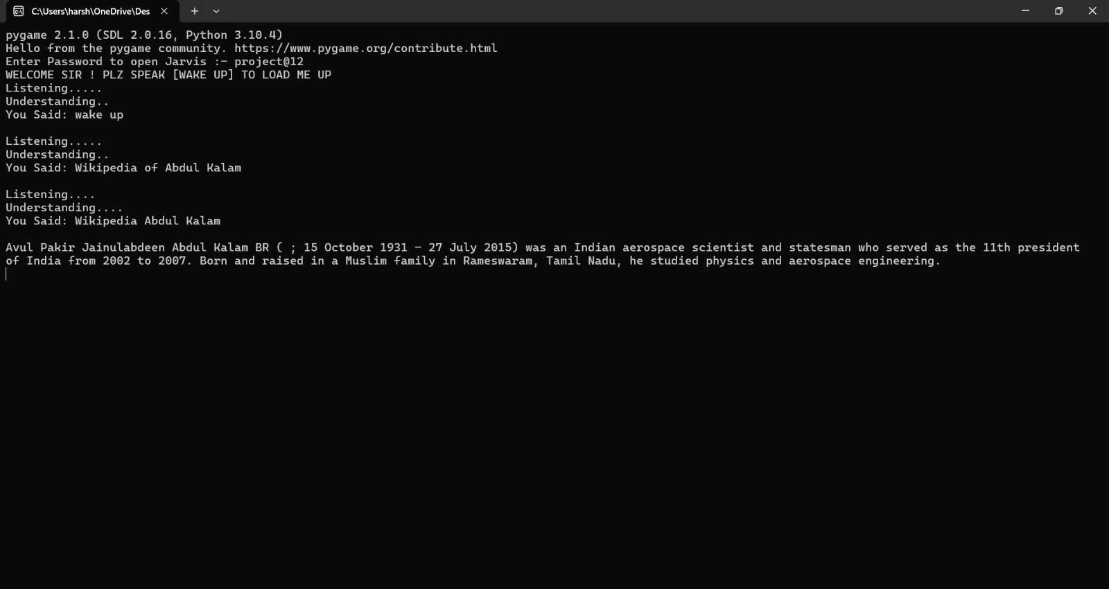

Implementation Result:-

**Conclusion:-** The later involved response generation, which manages

how entities and intents are treated to show useful content depending on the type of interaction between the user and the chatbot. It is also important to highlight the relevance of capturing this information as nodes of a decision tree and choosing a convenient flow of conversation. Future work is going to outline the influence of virtual assistants in the performance of students. Collaboration with other institutions and replication within similar and different educational contexts is needed in order to make further studies and obtain conclusive results about the impact of virtual assistants in education. For instance, the case of study was one particular implementation (for a very specific set of needs, in a narrow context), what we need is a broader set of contexts from which to capture the data generated by users and analyze it.

**Result**:-Our original methodology was limited because it only

considered the implementation side of things in terms of the components and the architecture. We talked about two stages of chatbot development, which were really two components of the software system: knowledge abstraction and response generation. The former is subdivided into: data gathering, which is providing the raw data; data manipulation, which manages and classifies data for design purposes; and data augmentation, which is an extra step for increasing the number of examples available for the training process of the machine learning model.

**Introduction:-**The use of virtual assistants such as Siri, Alexa, Google Assistant has increased in recent years and has become an important part of our daily lives. These virtual assistants use natural language processing and machine learning technology to help users interact with them using speech and tasks such as browsing the web, playing music, setting reminders and more. However, most virtual assistants are designed for mobile devices and there is a processing growing demand for similar systems on desktop computers. The aim of the research project is to create a virtual assistant for desktop computers that can perform various tasks using natural language and machine learning techniques. The proposed system is designed to help users perform various tasks such as browsing the web, managing documents, scheduling appointments and sending emails.The system uses a combination of speech recognition, natural language understanding, and speech management to allow users to interact with the assistant using spoken language. please improve The system consists of several stages, including data collection and preprocessing, model extraction, model training and evaluation, integration, and testing. The data used for training and evaluation is collected from various sources, including publicly available data and user interactions with the system.

|  |  |  |  |  |  |  |  |  |  |  |  |  |
| --- | --- | --- | --- | --- | --- | --- | --- | --- | --- | --- | --- | --- |
| **References**   1. *M. Bapat, H. Gune, and P. Bhattacharyya*, “A paradigm-based finite state morphological analyzer for marathi,” in Proceedings of the 1st Workshop on South and Southeast Asian NaturalLanguage Processing (WSSANLP), pp. 26–34, 2010. 2. *B. S. Atal and L. R. Rabiner*, “A pattern recognition approach to voiced unvoiced-silence classification with applications to speech recognition,” Acoustics, Speech and Signal Processing,IEEE Transactions on, vol. 24, no. 3,pp. 201–212, 1976. 3. *V.Radha and C. Vimala*, “A review on speech recognition challenges and approaches,” doaj. org, vol. 2, no. 1, pp. 1–7, 2012. 4. *T. Schultz and A. Waib*ch recognition”, SpeechCommunication, vol. 35, no. 1, pp. 31–51, 2001. | | | | | | | | | | | |  |
| Program Outcomes | | | | | |  | | | | | | |
| Po1 | Po2 | Po3 | Po4 | Po5 | Po6 | | Po7 | Po8 | Po9 | Po10 |  | |
| ✓ | ✓ | ✓ | ✓ | ✓ | ✓ | | ✓ | ✓ | ✓ | ✓ |
| Name and Sign of student   1. Ashvini Khobragde 2. Rupali Mamale 3. Pranay Lohabare 4. Shashank Mankar | | | | | | | | | | | | |